NexStep Biomarkers Installer:
- Build and Package PreclinicalEEGFramework.m
- Build NSB_SoftwareUpdate.m
- Generate Licence Files

After generating all necessary files including:

Open PowerArchiver and generate a SFX (self extracting file).
- set filename/destination in public dropbox
- add files to be included in package

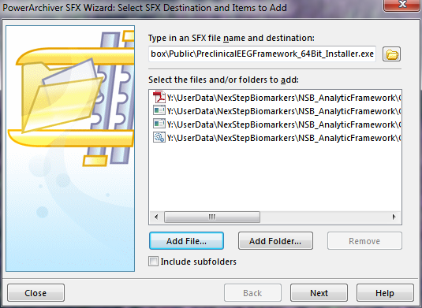

Set compression as CAB and store relative locations.

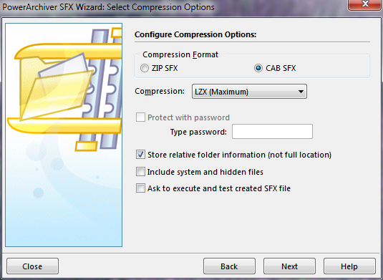
Set SFX options:
Normally these are the options to use…
with: Caption = NexStep Biomarkers EEG Framework
Run command = PreclinicalEEGFramework_installer.bat
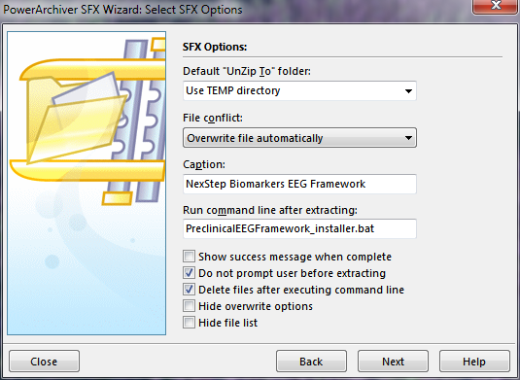

However in a Virtual Environment with poor permissions… try these.
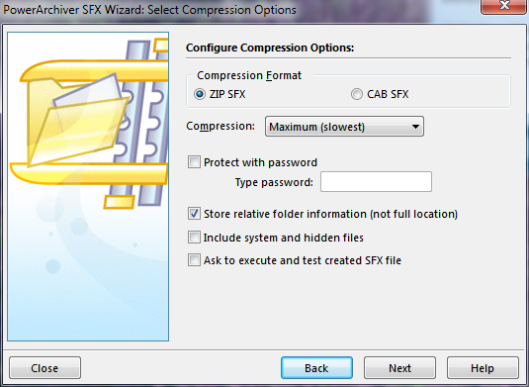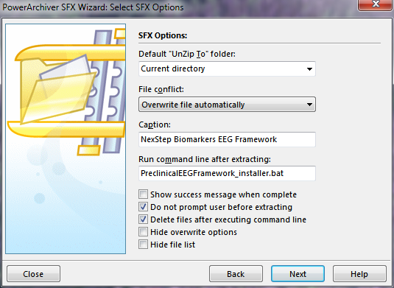

Make the SFX.
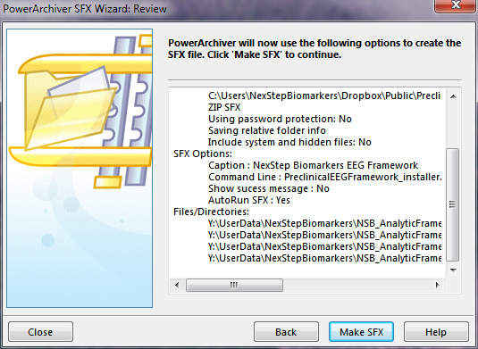

C:\Users\David\AppData\Local\Temp\mathworks_downloads\R2011b\

